1. Agenda:
   1. $set Update operator.
2. $set:
   1. Used in update methods in order to set value of a specified field or fields.
   2. $set: update object.
3. 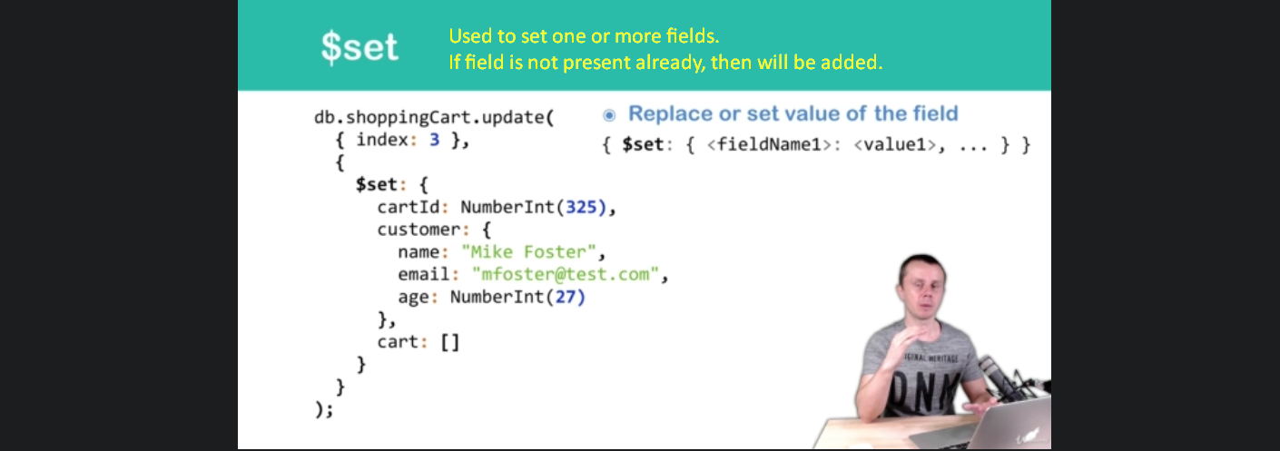
4. 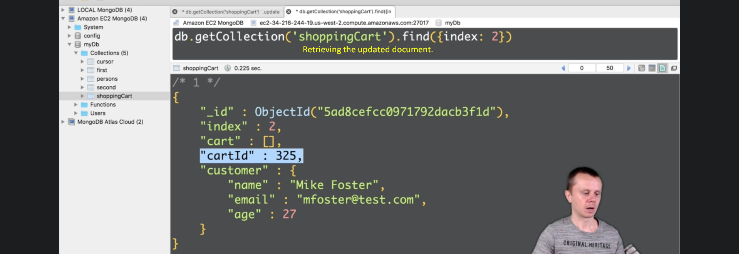
5. 